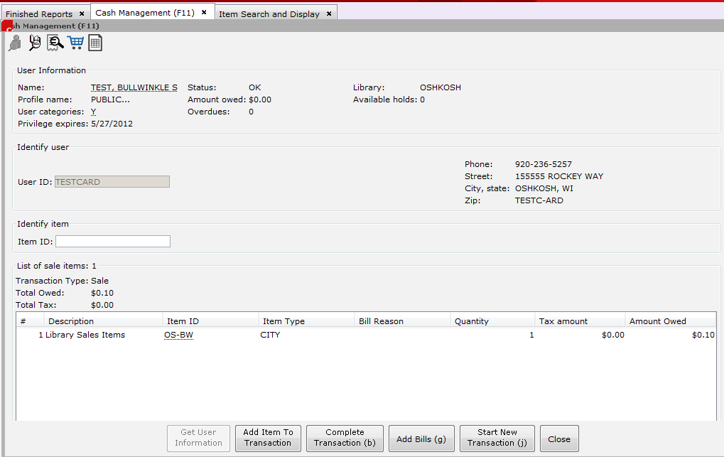
How do I remove an item?
6
Completing the transaction is confusing
5
8
The patron owes library fines and would like to pay them
2
I’m selling more than one of the same item
7
The Patron wants to make a donation.
I don’t know the User ID.
I don’t know the Item ID.
4
3
What are these?
1
1
Helpers: User Search, Item Search, Add Bills, Ad Hoc Sale, Till Summary

If the patron would like to pay existing fines, they can be added to the transaction with the Add Bills helper (the receipt and the magnifying glass, in the middle). They can also be added to the transaction by pressing the Add Bills button at the bottom of the page.
2
Both Add Bills helper and the Add Bills button add the fines to the transaction automatically, which can then be paid along with any other transactions.

3
It’s okay if you don’t know the User ID: you can key in the Item ID and complete a transaction without having a User ID, for guests or patrons who only wish to make a purchase and not pay their library fines in the same transaction.
If your patron does wish to pay their fine, and they don’t have their library card, you can use the User Search helper at the top to search for them.

4
Most Item IDs for purchasable items are text-based, and begin with your two-digit library code.
You can also find them by going up to the Item Search helper, and doing a Keyword Search (neither a Browse Search nor an Exact search finds the record) for “Library Sales Items”:
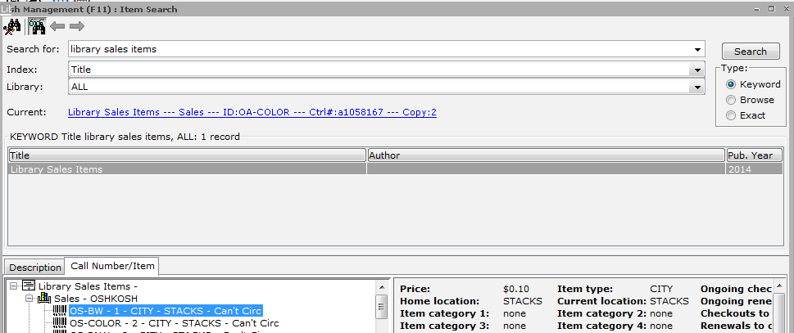

Each library has its set of purchasable items listed as a series of items under their “Sales – [Library]” call number heading. Immediately after the barcode icon is the Item ID: for example, OS-BW and OS-COLOR.
Either highlight the item and press “OK”, which adds the item to the transaction, or press “Cancel” and key in the Item ID manually into the Item ID field.
5Answer5
If the item is not under Library Sales Items, proceed to
5
Since donations are made for varying amounts, there is no Item ID set within WorkFlows. However, a donation can still be processed as a Cash Management transaction through the use of the Ad Hoc Sale Helper.
The Ad Hoc Sale Helper is also used if the patron is purchasing an item that does not have an Item ID within WorkFlows.
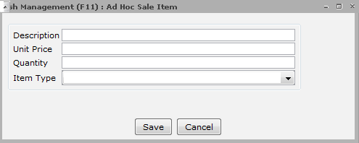
Click on the Ad Hoc Helper (the blue shopping cart along the top). Prompt window appears:

Description: Key in what item is being sold. (“Donation”) (If you receive reports that summarize transactions based on item type, make sure to use a standard term, with uniform capitalization and singular/plural. This ensures all Donations are calculated in a single line and not split out, as the computer calculates differences in case as different items.)
Unit Price: Key in how much
Quantity: Key in how many (usually 1)
Item Type: Select with drop-down box, depending on who receives the money: select “LIBRARY” if the proceeds go to the library, “FRIENDS” if the proceeds go to the Friends of the Library, etc.
Click Save, and item or donation is added to the transaction.

If you need to remove an item from the transaction, right-click on the Item ID and select “Remove Transaction Item”. When asked to confirm, select OK, and the item will be removed from the transaction.
6

7
There are three ways to add multiple copies of the same item to the transaction (ex: a three-page print job).
- Key in each instance of the item, until the desired number of items is reached (ex: three pages as three separate lines in the transaction display)
- Right click on the Item ID in the transaction display list. The Edit Sale Item box pops up: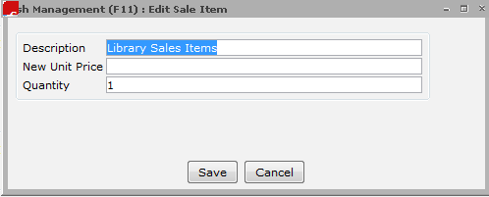
Enter new quantity (ex: 3) and click Save.
The transaction display then shows a single line for the print job, but with the Quantity of 3, for a total Amount Owed of $0.30

- Right click on the Item ID, and in the Edit Sale Item box, key in total to be owed in the New Unit Price box (ex: 0.30)
The transaction display then shows a single line for the print job, with a Quantity of 1, but an Amount owed of $0.30.
Changing the Unit Price under Edit Sale Item only changes it for that transaction; the next time the item is selected, the default price displays again.

To complete a transaction and process the patron’s payments, first click the “Complete Transaction” button.
8
The Make Payments window will open:
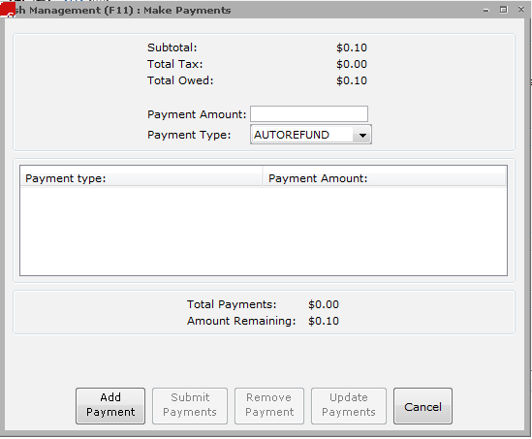
Enter in Payment amount.
This can be the full payment amount, or it can be a partial payment, if the patron would like to pay part of the transaction with one method and part with another (for example, half by cash and half on a credit card).
Select Payment Type from the dropdown box.
Click “Add Payment”.
If that was the total amount due, click Submit Payments to process the transaction. If the payment was a partial payment, continue to add payments until the total amount due is reached, and then click Submit Payments.

